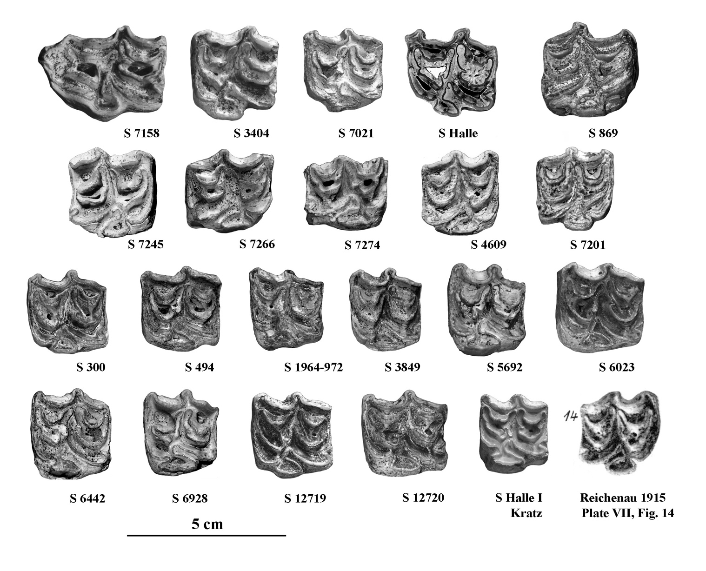

Figure S15. Occlusal views of upper cheek teeth of *E.* cf.  *wuesti*. All the accession numbers should be prefixed by IQW S.